Hands-on 5: Hello World RESTful Web Service

Objective
The objective of this exercise is to develop a simple RESTful Web Service using the Spring Web Framework. The application exposes a REST endpoint that returns the hard-coded response 'Hello World!!' when accessed through a web browser.

Software Requirements
• Eclipse IDE
• Java JDK 21
• Maven
• Spring Boot
• Spring Web
• Spring Boot DevTools
• Google Chrome

Steps Performed:
- Opened the existing spring-learn project in Eclipse.
- Created a new package named com.cognizant.controller.
- Created the HelloController.java class.
- Annotated the class using @RestController.
- Created the sayHello() method.
- Mapped the method using @GetMapping("/hello").
- Added start and end log messages inside the sayHello() method.
- Returned the hard-coded string "Hello World!!".
- Configured the application to run on port 8083.
- Executed the Spring Boot application successfully.
- Viewed the HTTP request and response headers using the Network tab in Chrome Developer Tools.

Project Structure:
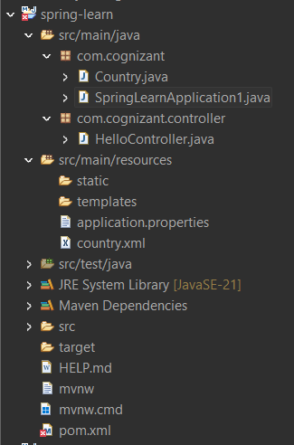
HelloController.java:
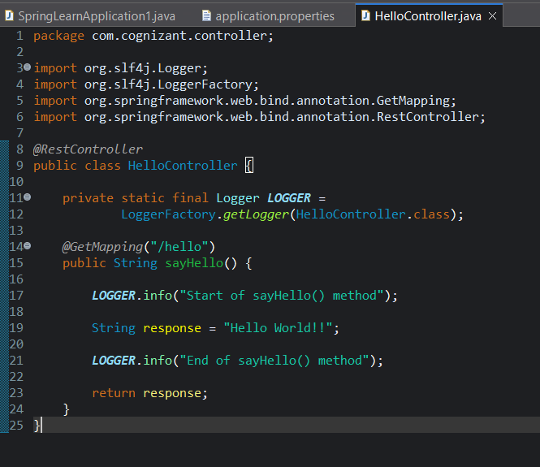

application.properties:
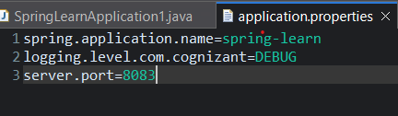

Browser Output:
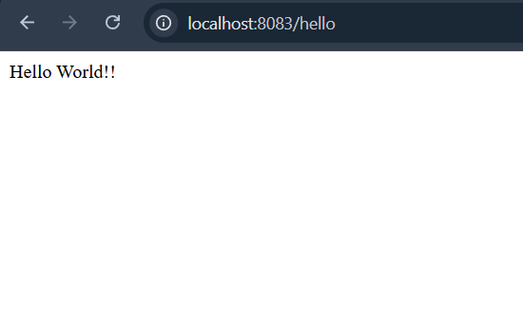

Explanation:
@RestController:
Marks the class as a REST controller and sends returned values directly as the HTTP response.
@GetMapping:
Maps an HTTP GET request to the sayHello() method.
sayHello() Method:
Handles the GET request, logs the start and end of execution, and returns the string "Hello World!!".
Spring Boot:
Automatically starts the embedded Tomcat server and publishes the REST endpoint.
HTTP GET Request:
Used to retrieve information from the server without modifying any date.

